**Assignment – 3**

**Name :** Kunal Hume

**Reg. No :** 2021BIT503

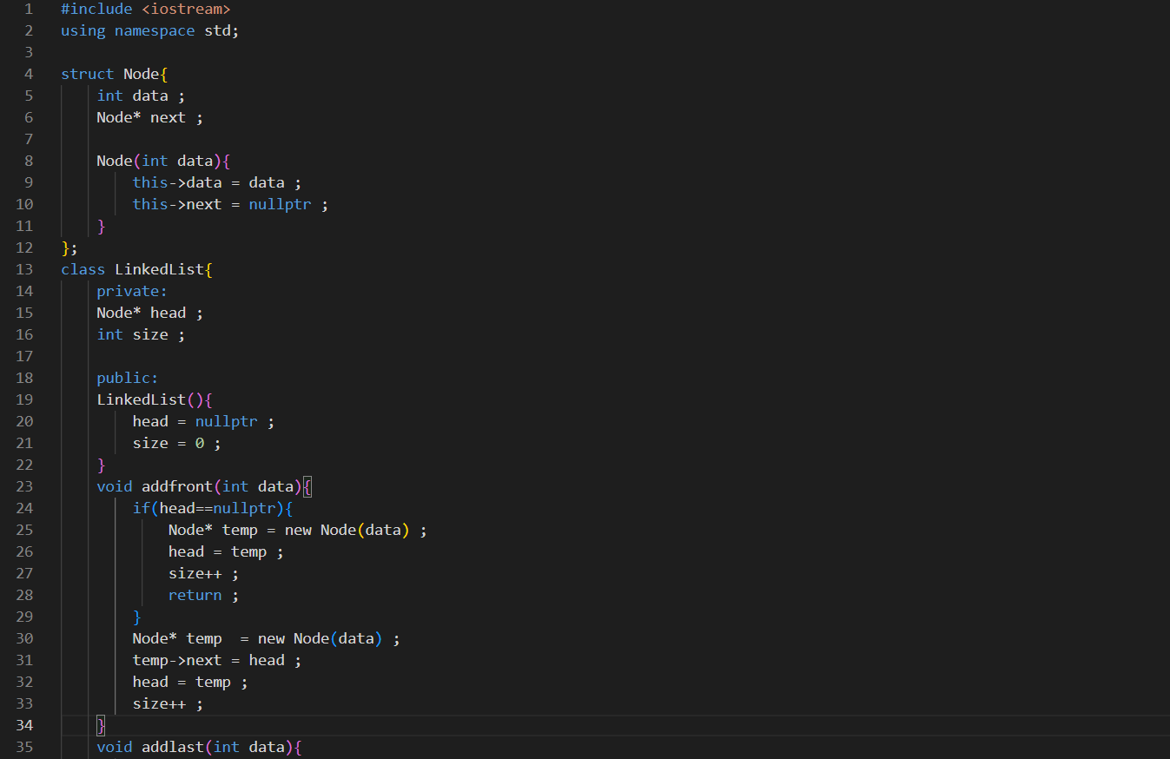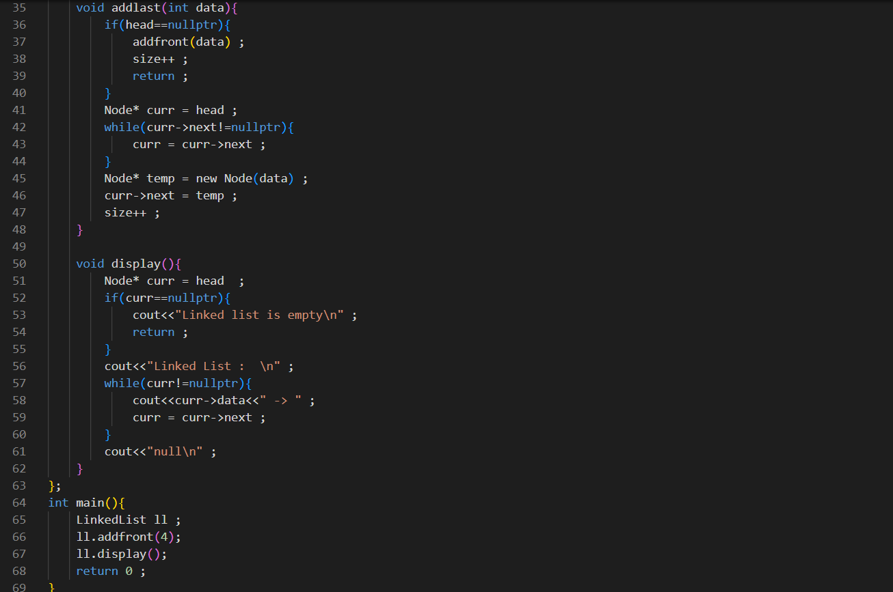

Output:

